**AP ASSIGNMENT – SHIVAM GAUTAM – 22BCS12184**

1. Climbing Stairs–

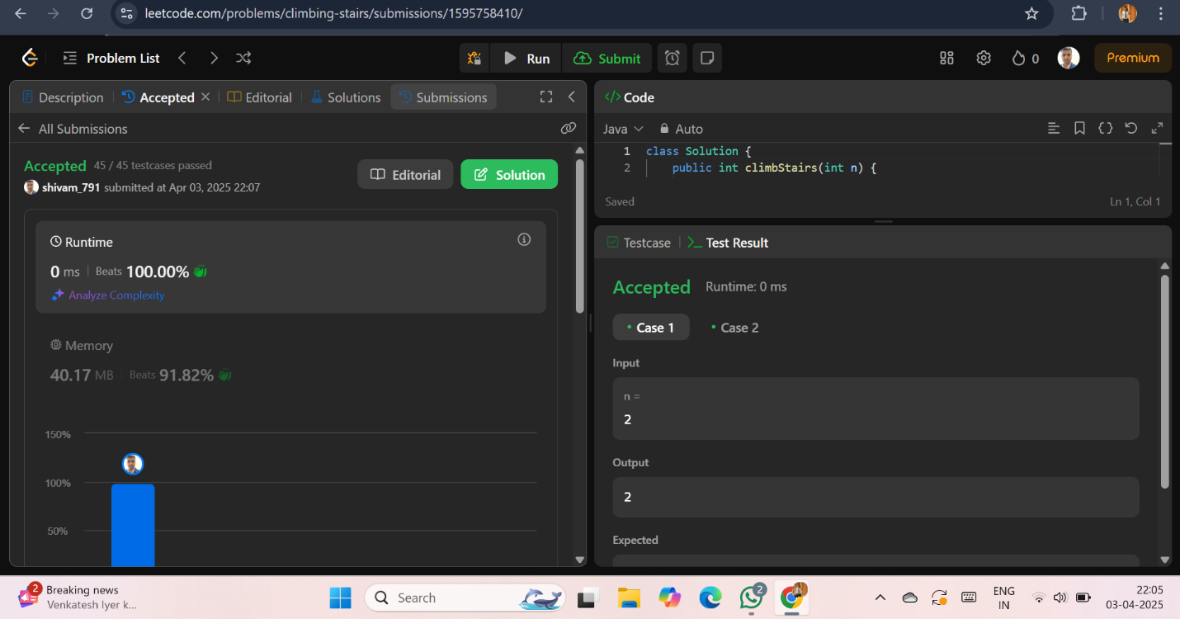

1. [Jump](https://leetcode.com/problems/remove-duplicates-from-sorted-list/description/) Game –

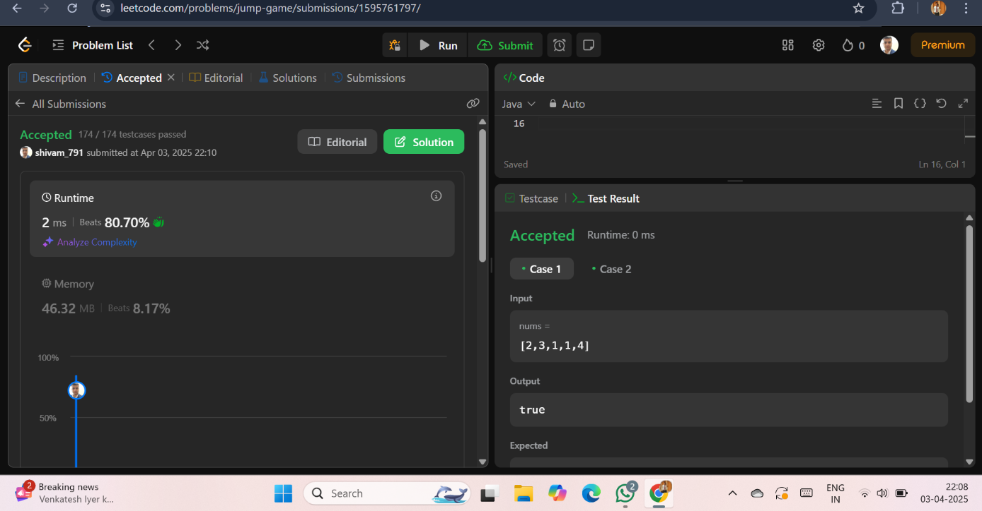

1. Maximum Product Sub-array –

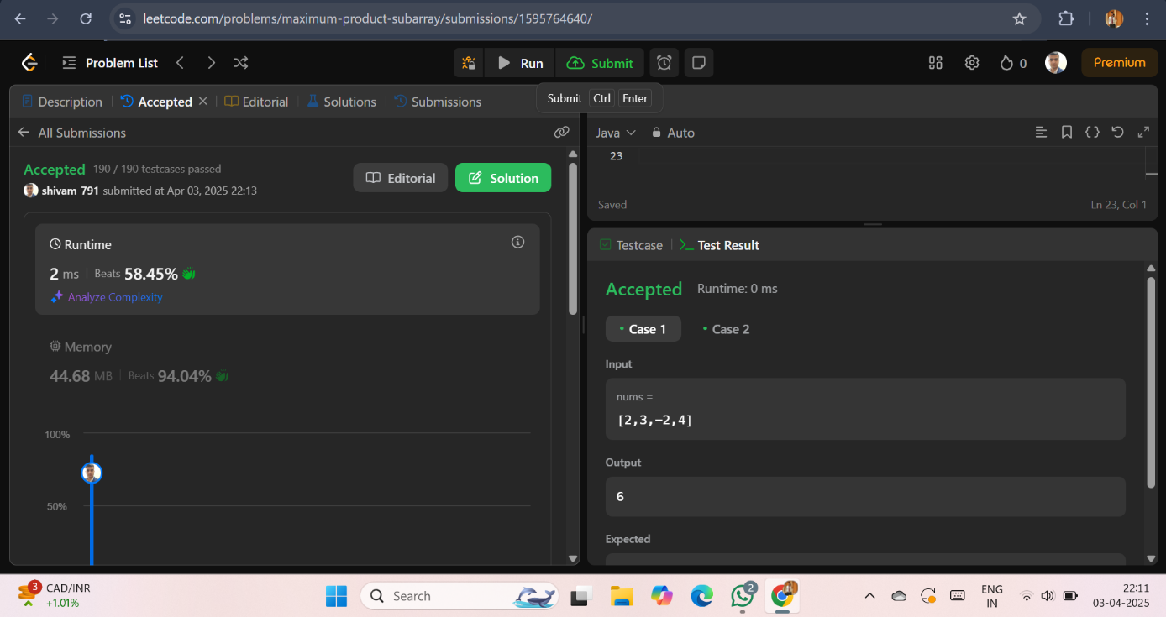

1. Perfect Square -

